Chapter 19, Solution 34.

Refer to Fig. (a) to get 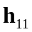 and 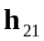.
100 
10 
I₁
1
+
V_{x}
−
+
V₁
−
−
+

10 V_{x}
50 
2
+
V₂ = 0
−
300 
I₂
(a)
At node 1,
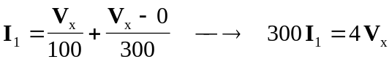 (1)
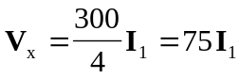

But 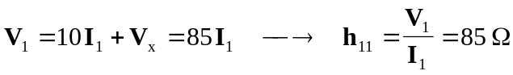
At node 2,
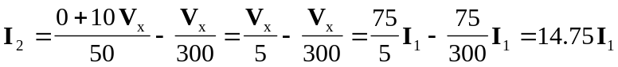
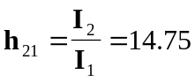

To get 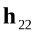 and 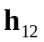, refer to Fig. (b).
100 
10 
1
+
V_{x}
−
+
V₁
−
−
+

10 V_{x}
50 
2
300 
(b)
I₁ = 0
+
−
I₂
V₂

At node 2,
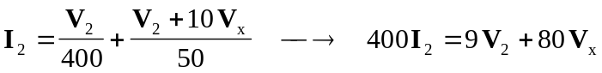
But 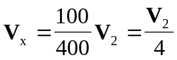
Hence, 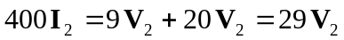
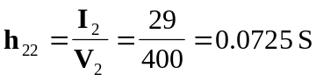

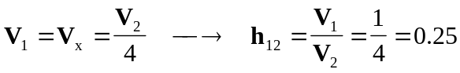

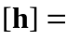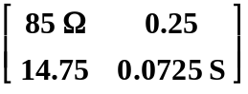

To get 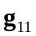 and 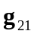, refer to Fig. (c).
100 
10 
1
+
V_{x}
−
+
V₂
−
−
+

10 V_{x}
50 
2
300 
(c)
+
−
I₂ = 0
I₁
V₁

At node 1,
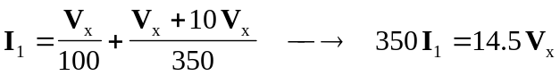 (2)

But 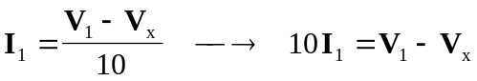
or 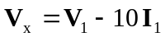 (3)

Substituting (3) into (2) gives
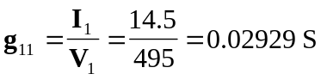
At node 2,
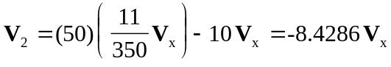
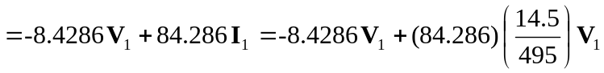

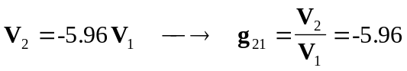

To get 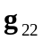 and 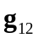, refer to Fig. (d).
100 
10 
+
V_{x}
−
−
+

10 V_{x}
50 
300 
(d)
I₂
+
V₂
−
I_{o}
I_{o}
+
V₁ = 0
−
I₁

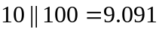

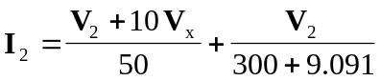

(4)

But 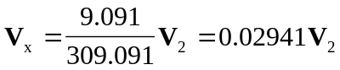 (5)

Substituting (5) into (4) gives

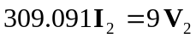
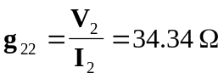

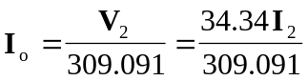

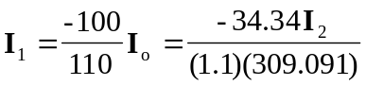
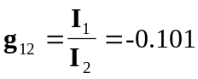

Thus,
